1. **SYSTEM ANALYSIS :-**
   1. **OVERVIEW :-**
      * **PURPOSE :**

The purpose of this project is to create an integrated E-Health Care Management System that caters to the needs of healthcare providers, staff, and patients. The scope of the system includes :

* Patient Information Management
* Electronic Health Records (EHR) Integration
* Appointment Scheduling and Management
* Prescription and Medication Tracking
* Billing and Insurance Claims Processing
* Communication and Collaboration Tools for Healthcare Professionals
* Patient Portal for Access to Health Information

The system aims to optimize healthcare processes, improve patient care, and provide a user-friendly platform for healthcare stakeholders.

* + - **FEARURES :**
      * **View Doctor:**
        + The "View Doctor" feature typically allows users to access detailed profiles of medical professionals within a healthcare platform or app. Users can browse through doctors' credentials, specialties, experience, and patient reviews to make informed decisions about their healthcare providers. This feature often includes filters for searching based on criteria like location, specialty, availability, and accepted insurance plans. It enhances transparency and trust between patients and doctors by providing comprehensive information. Patients can also view doctors' schedules and book appointments directly through the platform, streamlining the process. Additionally, some platforms offer video introductions or virtual tours of doctors' offices to help patients feel more comfortable with their choice. The "View Doctor" feature ultimately empowers patients to select healthcare providers who best meet their needs and preferences, fostering a more personalized and efficient healthcare experience.
      * **View Schedule:**
        + The "View Schedule" feature in a healthcare management system allows healthcare providers to access and manage their appointment schedules easily. It provides a centralized platform where providers can view upcoming appointments, patient details, and any relevant notes or medical history. This feature often includes customizable views, allowing providers to filter appointments by date, time, patient name, or type of appointment. Providers can also update appointment statuses, such as confirming, rescheduling, or canceling appointments, directly within the system. Furthermore, the "View Schedule" feature may integrate with other functionalities like patient reminders, waitlist management, and billing systems for a seamless workflow. It enhances efficiency by reducing administrative tasks and minimizing scheduling conflicts. Overall, this feature streamlines appointment management, ensuring a smooth and organized healthcare experience for both providers and patients.
      * **Book Schedule:**
        + The "Book Schedule" feature in a healthcare management system allows patients to schedule appointments with healthcare providers conveniently online. Users can access the system, view available appointment slots based on the provider's schedule, and select a suitable time slot for their visit. This feature often includes options to filter appointments by provider, location, specialty, or preferred time. Patients can input relevant information such as the reason for their visit and any specific requests or concerns. Once the appointment is booked, patients typically receive confirmation details and reminders via email or SMS. The "Book Schedule" feature may also integrate with the provider's calendar in real-time to ensure accurate availability and avoid double booking. Overall, this feature empowers patients to take control of their healthcare by enabling easy and efficient appointment scheduling from anywhere, anytime.
      * **Edit Schedule:**
        + The "Edit Schedule" feature in a healthcare management system enables healthcare providers to modify existing appointments swiftly and accurately. Providers can access their schedules, makes adjustment like rescheduling appointments or updating details, and save changes seamlessly. This feature typically offers search options for locating specific appointments based on patient names, dates, or appointment types, facilitating efficient edits. Providers can add notes or instructions to appointments to ensure all relevant information is conveyed. Integration with other system components like patient records and billing ensures consistency and coherence in patient care. Additionally, patients can be notified promptly of any changes made to their appointments, reducing inconvenience. Overall, this feature enhances flexibility and efficiency in managing schedules, enabling providers to adapt to evolving circumstances while maintaining the quality of care.
      * **Delete Schedule:**
        + The "Delete Schedule" feature in a healthcare management system allows healthcare providers to remove existing appointments from their schedules effortlessly. Providers can access the system, locate the appointment they wish to delete, and execute the deletion with a few clicks. This feature typically includes search functionalities for quick identification of appointments based on patient names, dates, or appointment types. Providers may also have the option to add notes or comments before deleting appointments to maintain accurate records. Integration with other system components ensures that relevant data, such as patient records and billing information, are updated accordingly. Additionally, patients can be notified promptly of any deleted appointments to avoid confusion or inconvenience. Overall, this feature streamlines schedule management, enabling providers to maintain an organized and up-to-date schedule with minimal effort.
      * **Feedback:**
        + The "Feedback" feature in a healthcare management system allows patients to provide their opinions, comments, and ratings regarding their healthcare experiences. Patients can access the system to submit feedback on various aspects such as the quality of care, communication with healthcare providers, waiting times, and overall satisfaction. This feature often includes options for patients to rate their experiences on a scale or provide written comments for more detailed feedback. Healthcare providers can view and analyse the feedback received to identify areas for improvement and enhance patient satisfaction. Integration with patient records helps to maintain a comprehensive view of each patient's feedback history. Additionally, patients may receive acknowledgments or responses to their feedback, fostering transparency and communication. Overall, the "Feedback" feature promotes patient engagement, quality improvement, and patient-centred care within the healthcare management system.
      * **View Article:**
        + The "View Articles from Doctors" feature in a healthcare management system allows patients to access educational articles and resources authored by healthcare providers. Patients can browse through a curated collection of articles covering various medical topics, treatments, and preventive care measures. This feature enhances patient education and empowerment by providing reliable information authored by trusted healthcare professionals. Patients can learn about their health conditions, treatment options, and ways to maintain wellness directly from their healthcare providers. The articles may include insights, tips, and recommendations tailored to specific patient demographics or medical needs. Integration with patient profiles allows healthcare providers to recommend relevant articles based on individual patient histories and concerns. Overall, the "View Articles from Doctors" feature promotes health literacy, fosters patient-provider communication, and supports informed decision-making in healthcare management systems.
  1. **FESIBILITY STUDY :-**

Feasibility Analysis is the process of determination of whether or not a project is worth doing. Feasibility studies are undertaken within tight time constraints and normally culminate in a written and oral feasibility report.

The objective behind the feasibility study is to create the reasons for developing the software that is acceptable to users, flexible to change and conformable to established standards.

There are three aspects in feasibility study

Feasibility study protion of the priliminary investigation.

Technical feasibility

Economic feasibility

Operational feasibility

1. **TECHNICAL FESIBILITY :**

Technical feasibility determines whether the work for the project can be done with the existing equipment, software technology and available personnel. Technical feasibility of proposed project refers to the software and hardware requirements.

The project is developing using HTML, CSS, PHP and other font end tool and MySQL is used for DBMS. The proposed project can be implementing on maximum browser support.

* 1. **TOOLS USED :-**

In our project the preliminary work has been started and I gathered client’s requirements, now I am designing after that we are going to start design for project.

* + - **HTML (HYPER TEXT MARKUP LANGUAGE) :**

HTML stands for Hyper Text Markup Language. HTML is not only way to present information on the web, but it’s the glue that holds everything to gather. In addition to being a markup language for displaying text, images and multimedia, HTML provides instructions to web browsers in order to control how documents are viewed and how they relate to each other. For all its simplicity, HTML is a very powerful language.

* HTML stands for Hyper Text Markup Language.
* An HTML file is a text file containing small markup tags.
* The markup tags tell the web browser how to display to the page.
* An HTML file must have an HTM or HTML extension.
* An html file can be created using a simple text editor.
  + - **CSS (CASCADING STYLE SHEET) :**

Cascading Style Sheets (CSS) is a style sheet language used to describe the presentation (that is, the look and formatting) of a document written in a Markup language. It’s most common application is to style web pages written in HTML and XHTML, but the language can be applied to any kind of XML document, including SVG and XUL.

CSS is designed preliminary to enable the separation if document content (written in HTML or a similar markup language) from document presentation, including elements such as the colours, fonts and layout. This separation can improve content accessibility, provide more flexibility and control in the specification of presentation characteristics, enable multiple pages to share formatting, and reduce complexity and repetition in the structural content (such as by allowing for table less web design).

CSS can also allow the same markup page to be presented in different styles for different rendering methods, such as on-screen, in print, by voice (when read out by a speech-based browser or screen reader) and on braille-based, tactile devices.

* + - **BOOTSTRAP :**

Bootstrap is a free and open-source tool collection for creating responsive websites and web applications. It is the most popular HTML, CSS, and JavaScript framework for developing responsive, mobile-first web sites. It solves many problems which we had once, one of which is the cross-browser compatibility issue. Nowadays, the websites are perfect for all the browsers (IE, Firefox and Chrome) and for all sizes of screens (Desktop, Tablets, and Phones). All thanks to Bootstrap developers -Mark Otto and Jacob Thornton of Twitter, though it was later declared to be an open-source project.

### Why Bootstrap

* + Faster and Easier Web-Development.
  + It creates Platform-independent web-pages.
  + It creates Responsive Web-pages.
  + It designed to be responsive to mobile devices too.

1. **ENTITY-RELATION DIAGRAM :-**

* **INTRODUCTION :**

An Entity Relation(ER) Diagram is a specialized graphics that illustrates the interrelationship between entities in a database. ER diagrams often use symbols to represent 3 different types of information. Boxes are commonly used to represent entities. Diamonds are normally used to represent relationships and ovals are used to represent attributes.

An Entity Relationship Model (ERM), in software engineering is an abstract and conceptual representation of data. Entity Relationship modelling is a relational schema database modelling method, used to produce a type of conceptual schema or semantic data model of a system, often a relation database, and its requirements in a top-down fashion.

* **COMPONENT OF ER DIAGRAM :**



Component Of E-R Diagram

Link

Entity

Attribute

Relationship

* 1. **ENTITY :**

Entity

Entity is the thing which we want to store information. It is an elementary basic building block of storing information about business process. An entity represents an object defined within the information system about which you want to store information. Entities are distinct things in the enterprise.

* 1. **RELATIONSHIP :**

**Relationship**

A relationship describes how entities interact. For example, the entity “carpenter” may be related to the “table” entity by the relationship “builds” or “makes”. Relationship are represented by diamond shapes and are labelled using verbs.

There are four type of relationship

|  |  |
| --- | --- |
| Types of relationship | Symbol |
| One to one relationship | 1 1 |
| One to many relationship | 1 N |
| Many to one relationship | N 1 |
| Many to many relationship | N N |

* 1. **ATTRIBUTE :**

**Attribute**

Attribute are the properties of the entities and relationship, descriptor of the entity.

Attribute are elementary pieces of information attached to an entity.

* 1. **LINK :**

Link is connected entity to attribute or attribute to entity.

1. **DFD [DATA FLOW DIAGRAM] :**
   1. 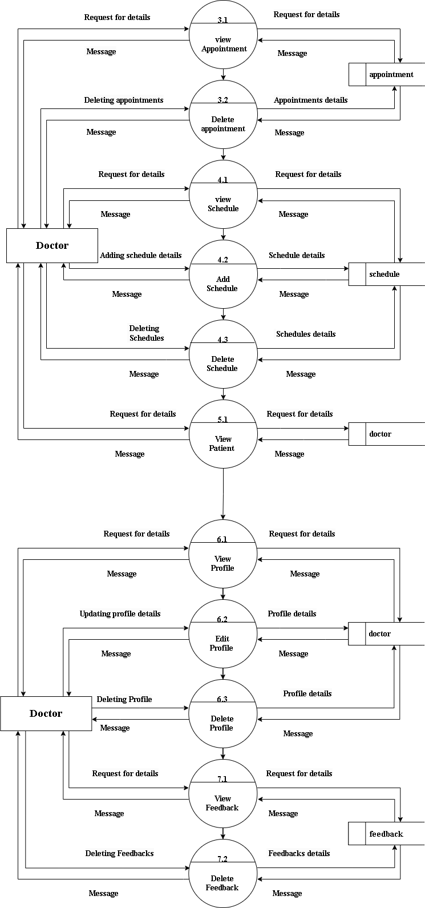**DOCTOR 2ND LEVEL :**

**To Be Continue …**



* 1. **PATIEN 2ND LEVEL :**

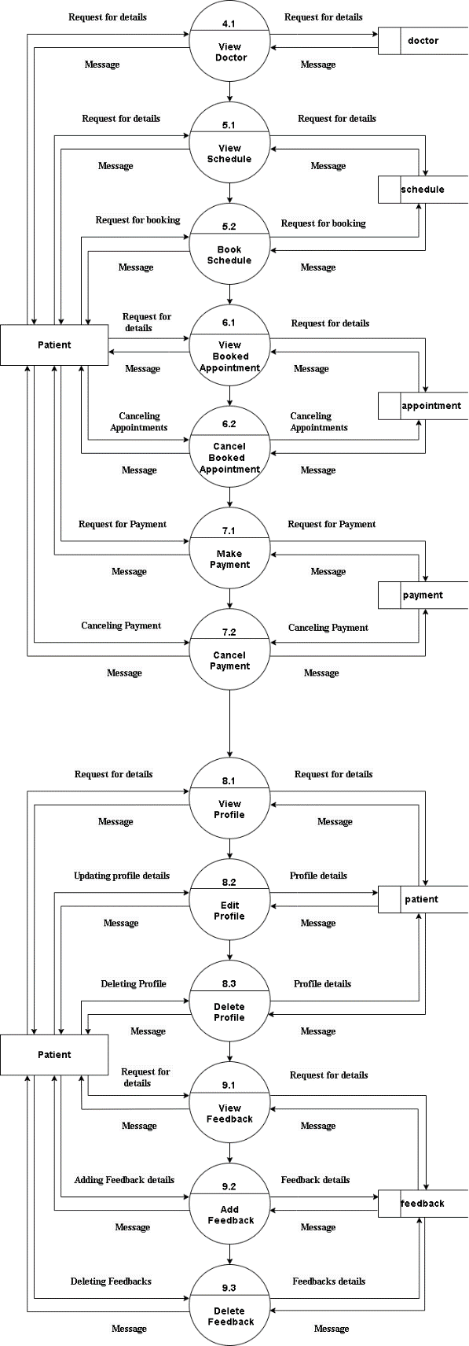

**To Be Continue…**

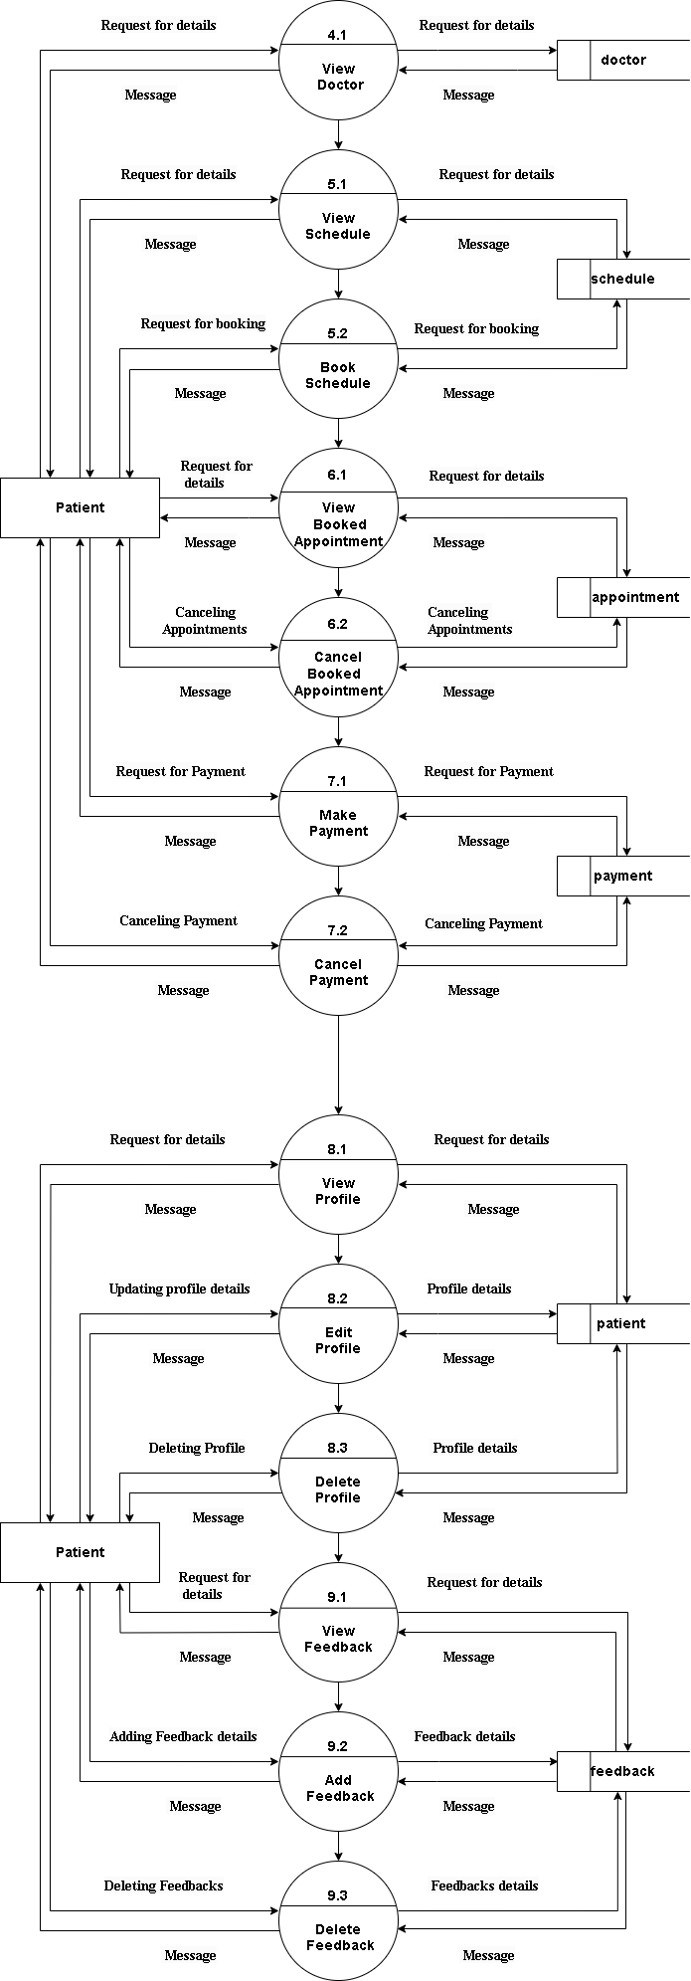

1. **SCREEN SHORTS:**
   1. **HOME PAGE :**

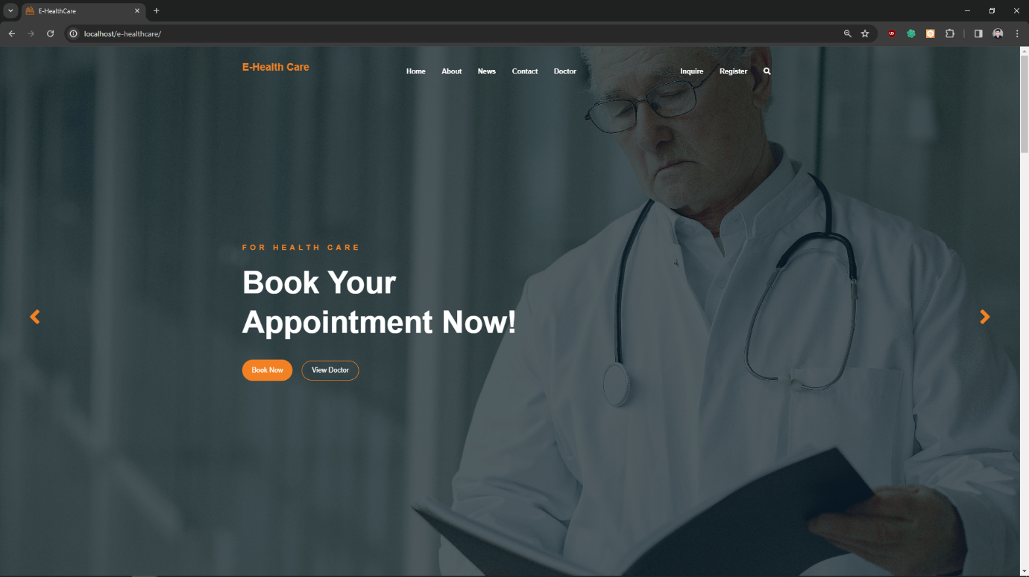

The home page in a healthcare management system serves as the central point of access for users, providing a snapshot of key information such as upcoming appointments, patient alerts, and task reminders. It allows users to navigate to different modules within the system, such as patient records, scheduling to streamline workflow and enhance efficiency. Notifications, announcements, and updates are also displayed on the home page to keep users informed and organized.

* 1. **LOGIN PAGE :**

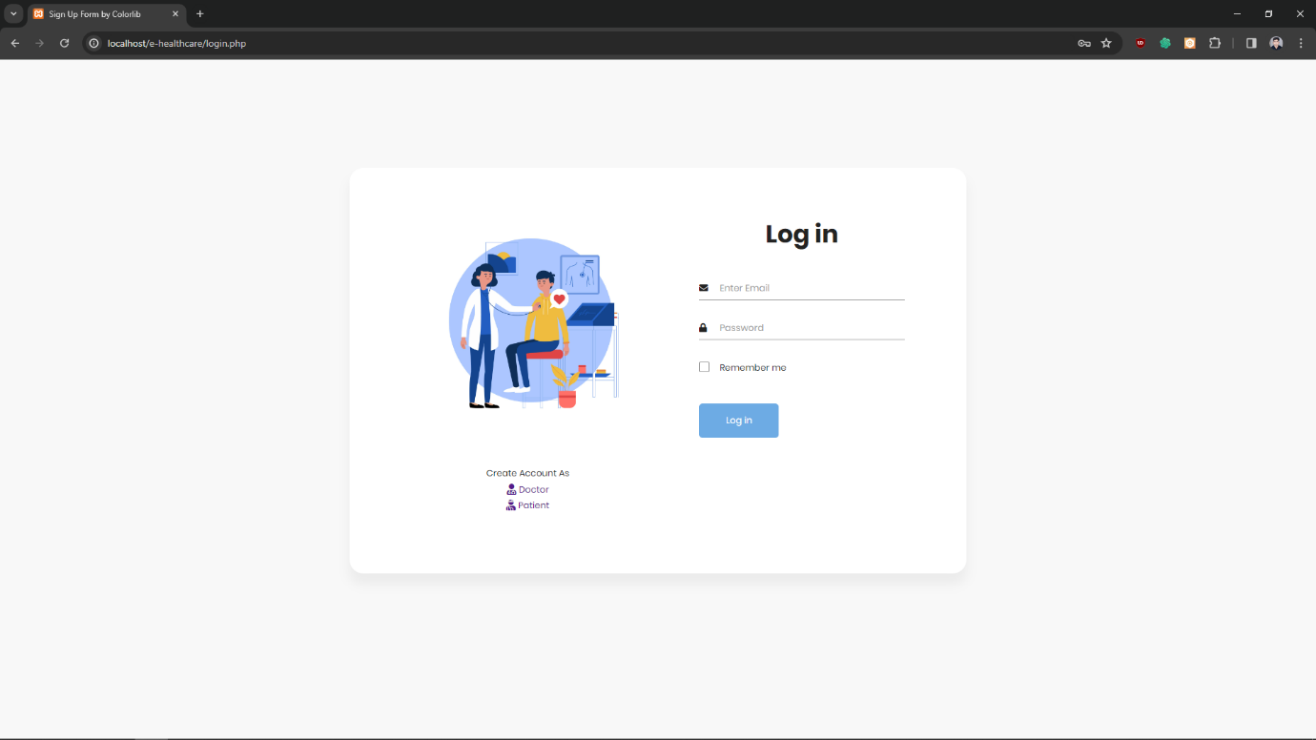

The login page in a healthcare management system is a secure portal where Authorized users, such as doctors and patient, can access the system by entering their unique credentials, such as username and password. This authentication process ensures that only approved individuals can view and update sensitive patient information stored within the system. The login page plays a crucial role in maintaining data security and privacy in healthcare settings.

* 1. **PATIENT REGISTRATION :**

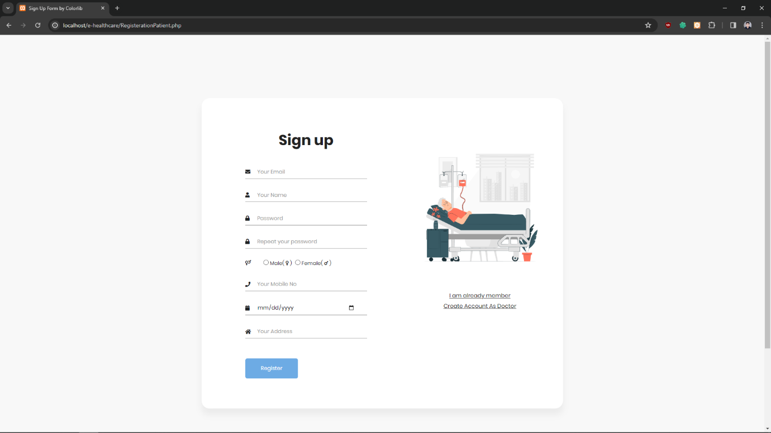

The patient registration page is a digital form where individuals can input their personal and medical information when becoming a new patient at a healthcare facility. This data also includes contact details . The registration page streamlines the process of creating electronic health records and helps healthcare providers better understand and care for their patients.

* 1. **PATIENT REGISTRATION CODE :**

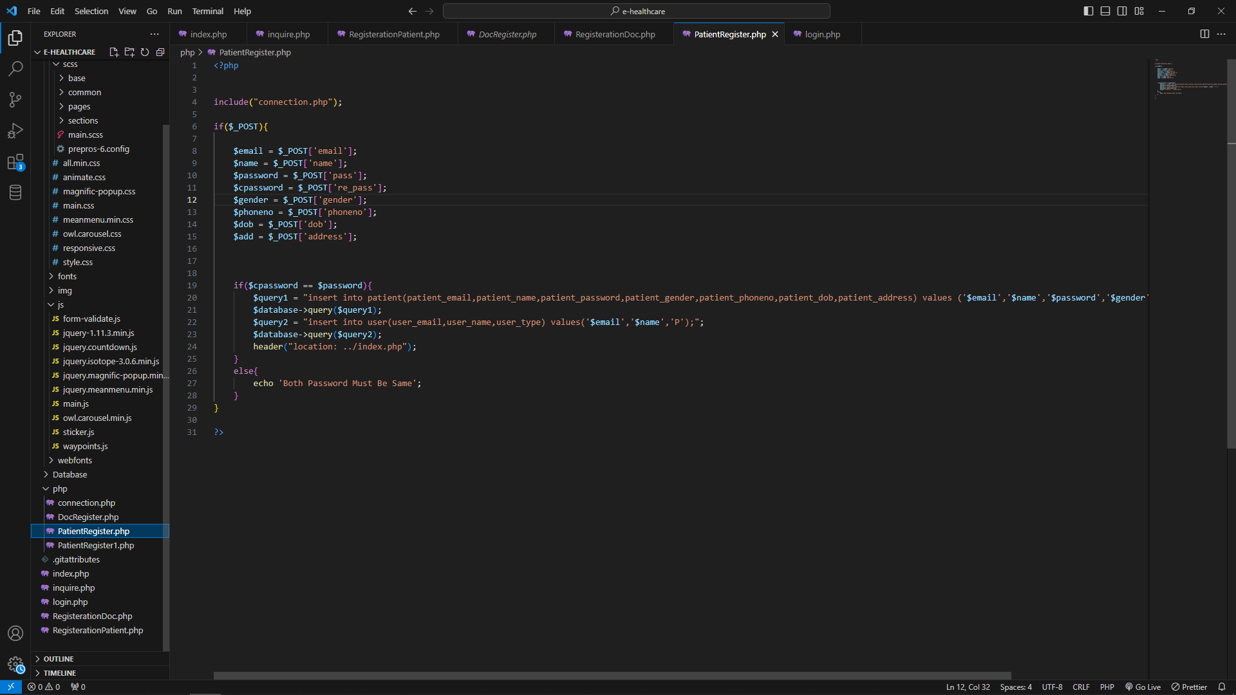

This Is Code Of Patient Registration With That Patient Can Register Him/her Self this Is Code Of PHP With That Data Of Patient Are Stored In Table Patient .

* 1. **EVENT PAGE :**

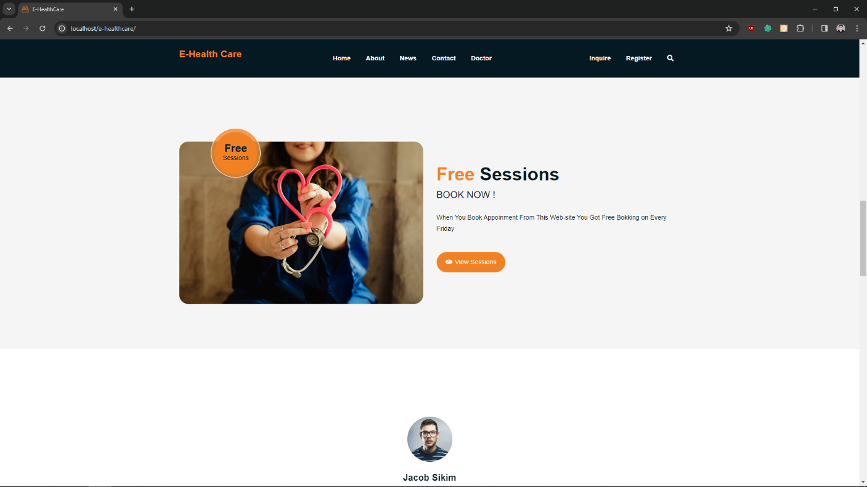

This Is Small Part Of Home Page which contain Some Event That Are On Upcoming Day That For Free Appointment Or Session Of Particular Doctor on Some Day’s.Like For Example Every Friday There is Free Appointment Where No Charge For Any Doctor on Appointment .

* 1. **INQUIRE PAGE :**

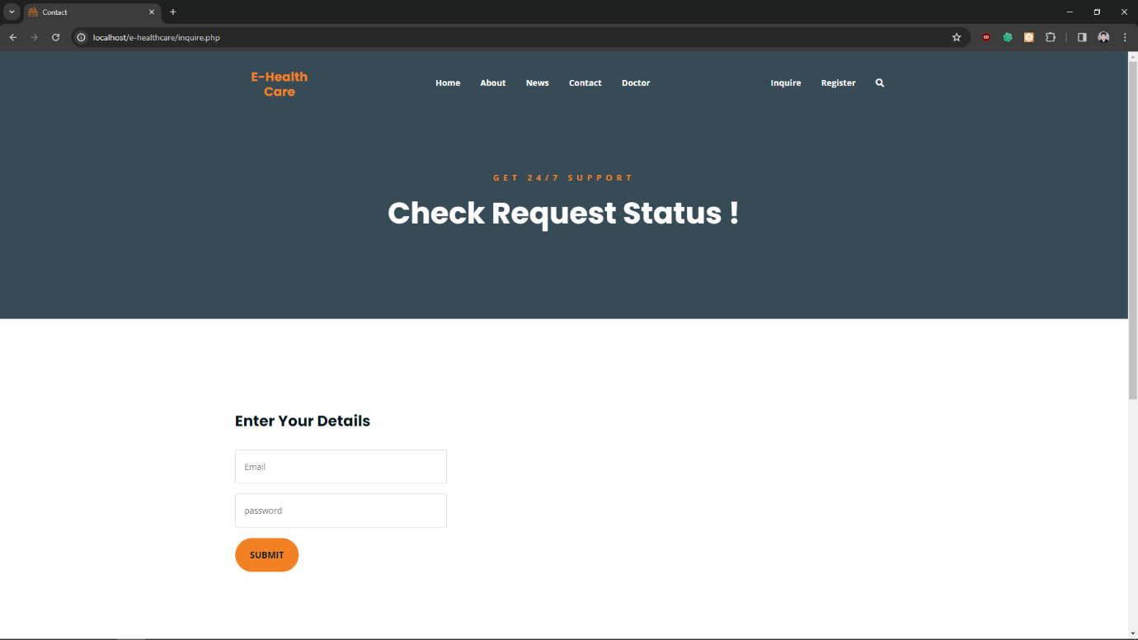

This Is inquire Page In That Doctor Are Check Their Status Either is approved Or Not If Approve Than Doctor Are Elegeble TO Login Other Wise Not Login   
this Approved Are Done By Admin.

* 1. **INQUIRE CODE:**

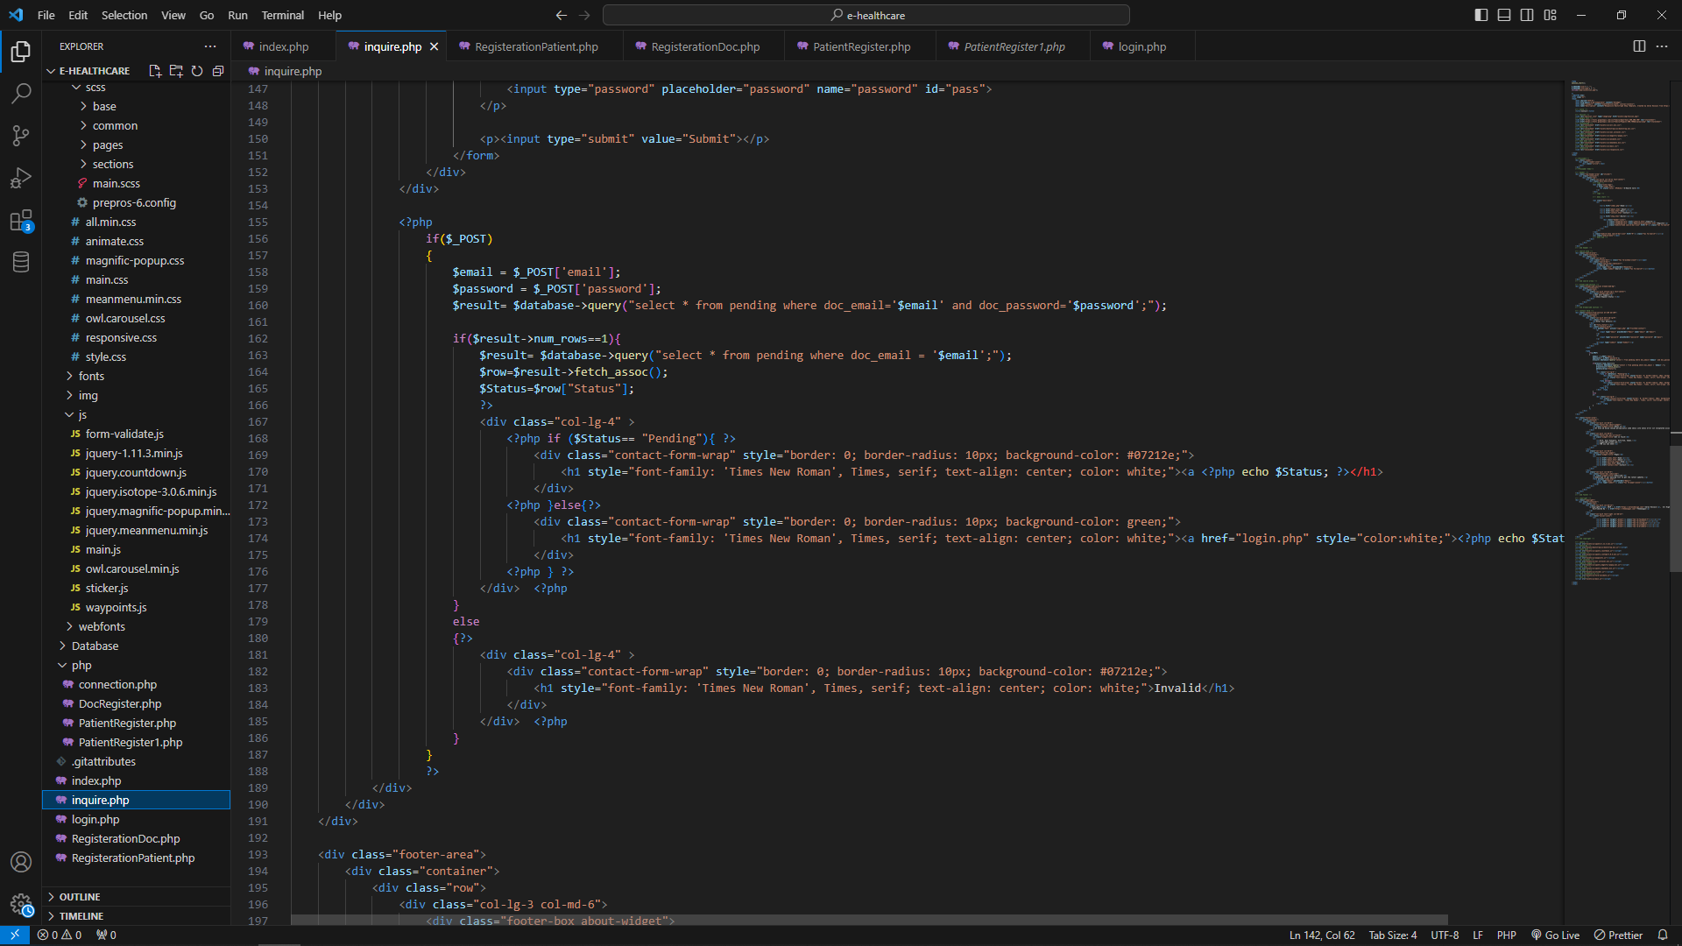

This Is Code OF Inquire Page Which Display Approve Or Reject Or Pending On Doctor’s Details That Applied By Admin .